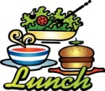
MAY 2022
FRIEND SCHOOL

Monday | Tuesday | Wednesday | Thursday | Friday
16 Cereal, Toast, Jelly, Fruit  Chicken Taquito, Refried Beans, Rosy Applesauce, Chocolate chip cookie | 17 Cinnamon Roll, Fruit  Pre-K & KG Chicken Slider  1st -8th Beef Sliders  Cheese, Leaf Lettuce, Pickles, Cheetos, Peaches | 18 Biscuit & Bacon, Jelly, Fruit  Pre-K & KG Hot Dog (no chili)  1st -6th Corndog  7th-8th Steak Fingers Pork&Beans, Peaches, Oreo | 19 Chef’s Choice, Fruit  PB&J, Chips, Raisins, Carrots w/Ranch, Oatmeal Bar
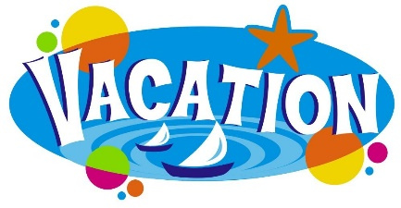 |  | SEE YOU IN AUGUST |  | 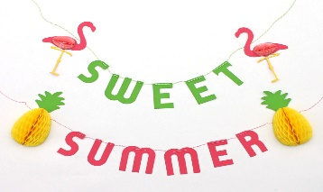
THIS INSTITUTION IS AN EQUAL OPPORTUNITY PROVIDER.

